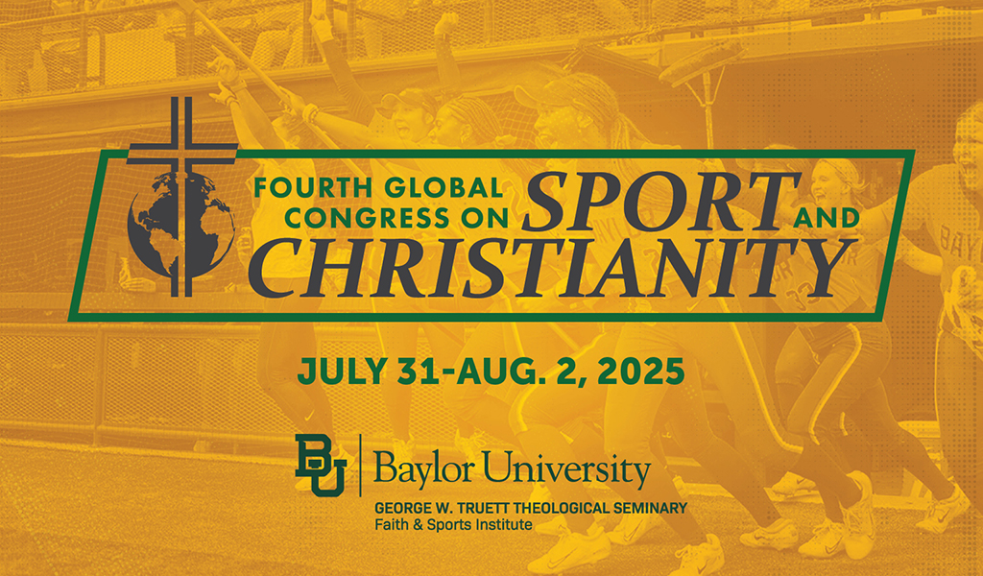

**The Fourth Global Congress on Sport and Christianity**

**Host:** The Faith & Sports Institute at Baylor University’s Truett Seminary

**Conference Coordinator:** [Paul Putz](mailto:paul_putz@baylor.edu)

Since 2016, the triennial Global Congress on Sport and Christianity (GCSC) has provided an interdisciplinary and collaborative space for meaningful exploration of sport and Christianity among scholars and practitioners. The Program Committee for the fourth GCSC seeks to continue the conversation. We invite proposals featuring research, scholarship, and/or reflection on sport and Christianity, in all of its forms.

Proposals are welcome from all backgrounds and communities, with the hope that our gathering can be a truly global and diverse meeting:

* From scholars, we welcome proposals in fields such as theology, religious studies, sport studies, exercise science, psychology, history, philosophy, ancient and modern languages, literature, sport management, anthropology, sociology, cultural studies, economics, business, and more.
* From practitioners, we welcome proposals shaped by experience in fields such as ministry, sport ministry, mission work, counseling, social work, sport administration, teaching/education, coaching, and more.

We are interested in proposals that feature both academic/scholarly and applied/practitioner perspectives. Graduate and undergraduate students are encouraged to apply.

**Themes:**This conference is structured around four broad themes. Accordingly, any proposals should be designed to explore the intersection of sport and Christianity in relation to at least one of the four:

1. **Theme 1: Identity and Belonging**. Possible topics: generational culture shifts; social justice; race and ethnicity; gender and sexuality; performance issues; relationships and community; and more.
2. **Theme 2: Embodiment and Health**. Possible topics: disability; fitness; tech/AI; mental health; sport performance; human body; and more.
3. **Theme 3: Moral Education and Discipleship**. Possible topics: values in sport; work, play, and rest; evangelism and witness; soul training; character formation; and more.
4. **Theme 4: Culture Building and Institutions**. Possible topics: sustainability and development; leadership; church and sport; team building; sport industry; pluralism; cultural engagement; and more.

**Instructions:**Proposals should include abstracts of 150-200 words and must be submitted using [this form.](https://docs.google.com/forms/d/e/1FAIpQLSe_nyeWr_FkJdZQB6zxpr3NV5YeysVnnYcffYNNK-Ykzp4uLw/viewform?vc=0&c=0&w=1&flr=0) For guidance on how to write a conference proposal, please visit our [FAQ page.](https://truettseminary.baylor.edu/programs-centers/faith-sports-institute/global-congress-sport-and-christianity/faq-2025-global) In general, reference to published scholarship, relevant references/sources, and/or existing bodies of work on the proposal topic is encouraged.

**Proposal Types:**Proposals can be submitted for any of the following three presentation types:

1. **Individual Presentation**. These involve a presentation from one individual, usually between 15-20 minutes, which the program committee will then group into appropriate panel sessions.
2. **Group Panel Session**. These presentations take one of two forms.
   1. *Regular panels* are composed of 3 or 4 presenters and a respondent. Presenters are given 15-20 minutes each, with 10 minutes for discussion of the papers;
   2. *Roundtables* are composed of up to five people, including the chair, and may involve short presentations (around 5 minutes) from each panelist and then a facilitated conversation.
3. **Poster Session**. These include an abstract just like a proposal for an individual presentation, but the content will be displayed via a poster, and discussed by the author during the poster session portion of the conference.

The deadline for submission of all types of presentations is Wednesday, January 31, 2025. PLEASE SUBMIT ALL PROPOSALS THROUGH THIS FORM.

[Submit Presentation](https://docs.google.com/forms/d/e/1FAIpQLSe_nyeWr_FkJdZQB6zxpr3NV5YeysVnnYcffYNNK-Ykzp4uLw/viewform?vc=0&c=0&w=1&flr=0)

Please note that the form will ask for biographical information, the proposal type, and the theme in which the proposal author believes the abstract fits best.  
  
Letters of acceptance or rejection will be sent by March 15, 2025. The Program Committee will evaluate all submissions according to their individual merit, contribution to the field, and fit within the total program. Please email Proposal Review Committee co-chair Chad Carlson with any questions related to proposals.  
    
**Important: Implicit Agreement to Attend Conference.** Submission of a proposal indicates the authors’ intent to register for the conference at the appropriate conference fee and to be available to present on any of the days of the conference.